**Analysis and Findings**

1. The accompanying bar graph shows the percentage of reservations that are cancelled and those are not. It is obvious that there are still significant number of reservation that have not been cancelled. There are still 37% of clients who cancelled their reservation, which has a significant impact on the hotel’s earnings.

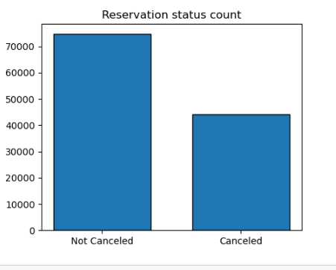

1. In comparison to resort hotels, city hotels have more bookings. It’s possible that resort hotels are more expensive than those in cities.

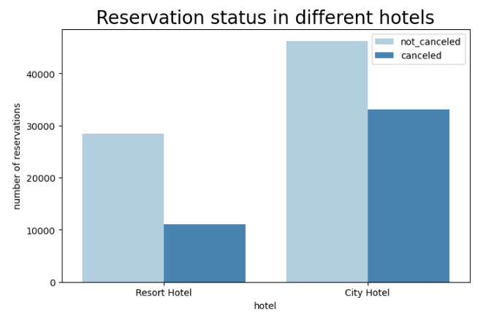

1. The line graph above shows that on certain days the average daily rate for a city hotel Is less than that of a resort hotel and on the other days it is even less. It goes without saying that weekends and holidays may see a rise in resort hotel rates.

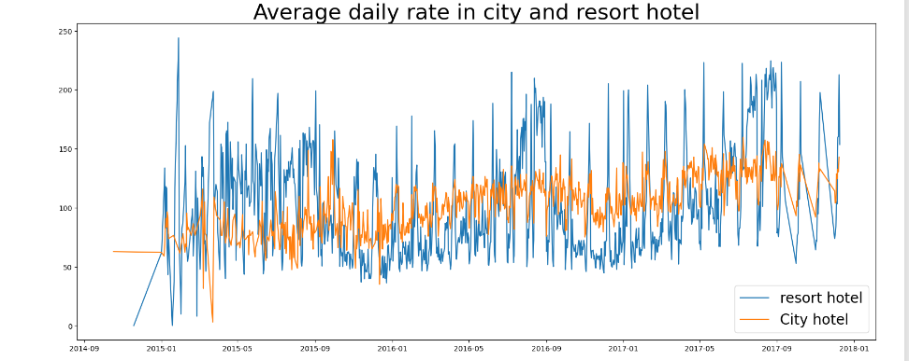

1. We have developed the grouped bar graph to analyse the months with the highest and lowest reservation levels according to the reservation status. As can be seen both the number of confirmed reservations and the number of cancelled reservations are largest is the month of august whereas January is the month with the most cancelled reservation.

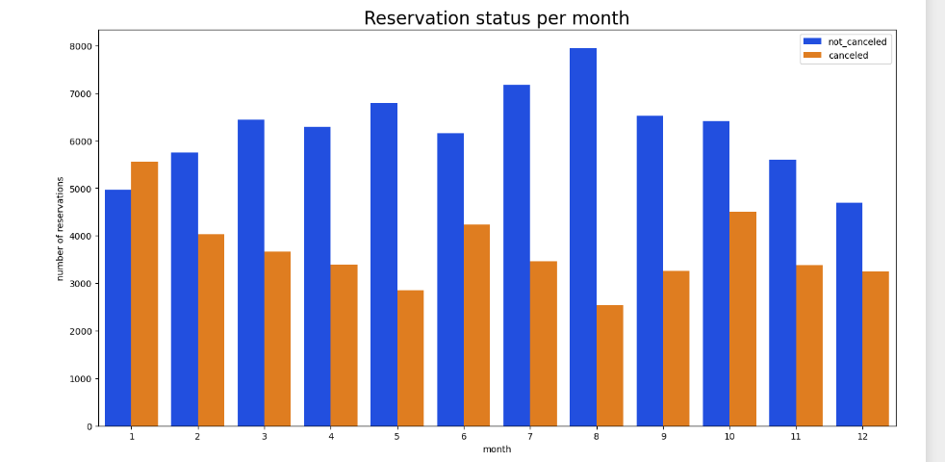

1. This bar graph demonstrates that cancellations are most common when prices are greatest and are least common when they are lowest. Therefore the cost of the accommodation is solely responsible for the cancellation.

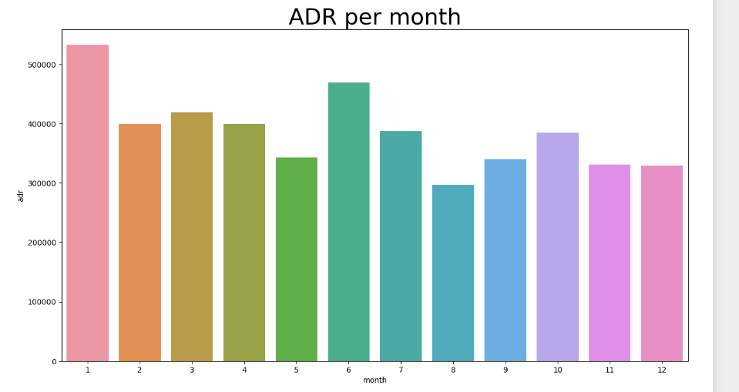

1. Now, let’s see which country has the highest reservation cancelled. The top country is Portugal with the highest number of cancellations

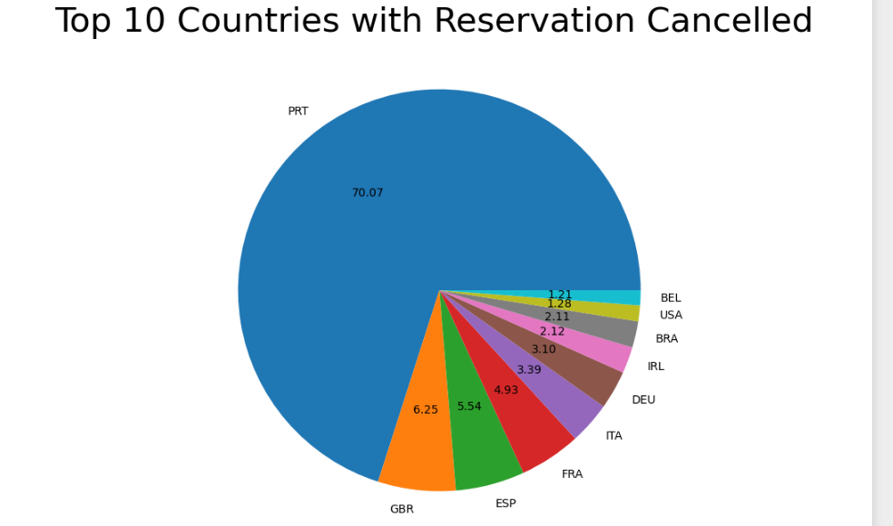

1. Let’s check the area from where guests are visiting the hotels and making reservations is it coming from direct or groups, online or offline travel agents? Around 46% of the clients come from online travel agencies, where as 27% come from groups. Only 4%of clients book hotels directly by visiting them and making reservations.  
     
   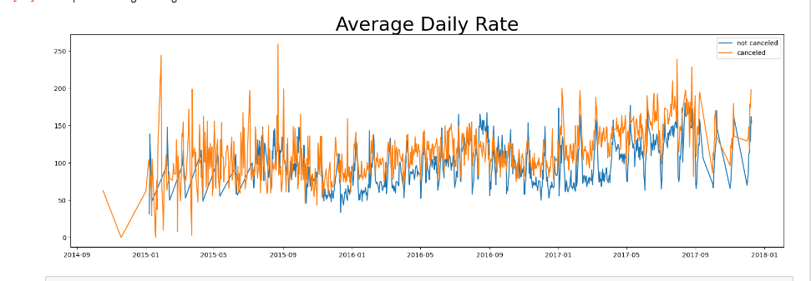

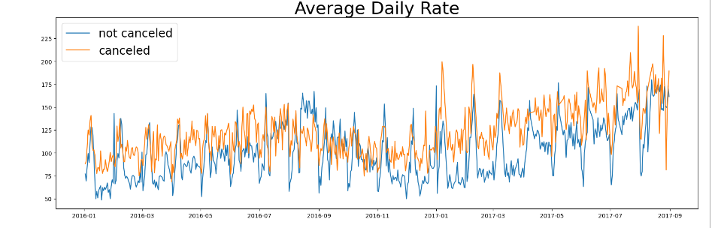

As seen in the graph reservations are cancelled when the average daily rate is higher than when it is not cancelled. It clearly proves all the above analysis that the higher price leads to higher cancellation

**Suggestions:**

1. Cancellation rates rise as the prices does. In order to prevent cancellations of reservations, hotels could work on their pricing strategies and try to lower the rates for specific, hotels based on locations. They can also provide some discounts to the consumers.
2. As the ratio of the cancellation and not cancellation of the resort hotel is higher in the resort hotel than the city hotels. So the hotels should provide a reasonable discount on the room prices on weekends or on holidays.
3. In the month of January hotels can start campaigns or marketing with the reasonable amount to increase their revenue as the cancellation is the highest in this month
4. They can also increase the quality of their hotels and their services mainly in the Portugal to reduce the cancellation rate.